**Report**

|  |  |
| --- | --- |
| Date | 24 June 2025 |
| Team ID | PNT2022TMIDxxxxxx |
| Project Name | Predicting plant growth stages with environmental and management data using power bi |
| Maximum Marks | 5 Marks |

A report is a comprehensive document that provides a detailed and structured account of data analysis, findings, and insights. It is typically used for in-depth analysis, documentation, and communication of results. Reports are suitable for a diverse audience, including decision-makers, analysts, and stakeholders who need a comprehensive understanding of the data.

Designing a report in Power BI involves connecting to data sources, creating visualizations like charts and graphs, customizing their appearance and interactivity, organizing them logically on the canvas, formatting elements for consistency and clarity, and optionally creating dashboards for a summarized view. Throughout the process, it's essential to consider the audience's needs and ensure the report effectively communicates insights from the data. Finally, iterate based on feedback to continually improve the report's design and usefulness.

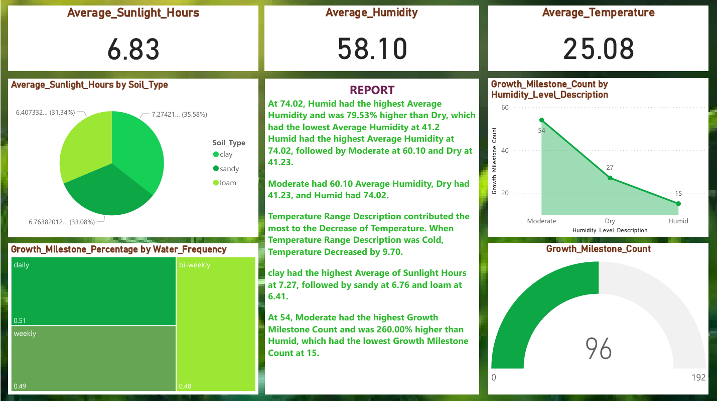

*Observations drawn from reports in Power BI can provide valuable insights into business performance and trends.*

### ****1. Moderate Humidity Drives the Highest Growth Milestones****

The Growth Milestone Count by Humidity Level Description chart reveals that:

* **Moderate humidity** conditions lead to the highest number of plant growth milestones (**54**),
* Followed by **Dry** (27), and **Humid** (15).

This suggests that while high humidity may be good for moisture retention, moderate humidity strikes a better balance for optimal plant development.

### ****2. High Humidity Doesn’t Guarantee Higher Growth****

Despite Humid conditions having the **highest average humidity** of **74.02%**, they resulted in the **lowest growth milestone count** (15), as noted in the report. In contrast, **Moderate** humidity, with an average of **60.10%**, yielded the most growth.

* This highlights that extremely high humidity may hinder growth, possibly due to over-saturation or fungal risk.

### ****3. Cold Temperatures Significantly Lower Growth Potential****

The report notes that when the Temperature Range Description wasCold, the **temperature decreased by 9.70 units**, which negatively affected plant growth. This reinforces the trend that colder climates are not suitable for optimal growth, emphasizing the need for warm-to-moderate temperatures.

### ****4. Clay Soil Receives the Most Sunlight****

According to the pie chart and report:

* **Clay soil** had the **highest average sunlight hours** (7.27),
* Followed by **sandy** (6.76),
* And **loam** with the least (6.41).

This implies that clay-based plots receive better sun exposure, which could be beneficial if temperature and water conditions are well managed.

**5. Balanced Water Frequency Leads to Better Growth**

The Growth Milestone Percentage by Water Frequency treemap shows:

* **Daily watering** leads the chart (0.51 or 51%),
* Followed closely by **weekly** (0.49),
* **Bi-weekly** watering has the lowest milestone share (0.48).

This means frequent and consistent watering schedules support healthier growth, while less frequent watering may not provide enough moisture.

**6. Overall Growth Milestone Count Stands at 96**

The gauge chart at the bottom-right shows a **total growth milestone count of 96** out of a possible maximum (192). This helps measure overall progress and suggests that there is potential to double the plant growth performance through improved environmental management and input strategies.

**7. Average Metrics Snapshot**

From the KPI tiles at the top:

* **Average Sunlight Hours**: 6.83 hours
* **Average Humidity**: 58.10%
* **Average Temperature**: 25.08°C

These average conditions provide a baseline reference for evaluating whether current plant environments are within an optimal range or need adjustment.

**Conclusion**

The dashboard insights help farmers, agronomists, and researchers:

* Identify the ideal humidity and watering schedules,
* Understand how temperature and sunlight affect growth by soil type,
* Focus on moderate conditions for maximum plant development,
* Track progress toward total growth potential.